What is JSON API Collection?
JSON API Collection contains the All sample transactions that would generate the stimulated response from our Virtualized Sandbox instance. Consumers can run the specific transaction per their business need & successfully integrate their code with FedEx API.

How to find the specific transaction that would fit my business use case scenario?
- Step 1: Locate the “Lookup test case Tool” excel in the Ship API JSON Collection downloaded in your local drive.

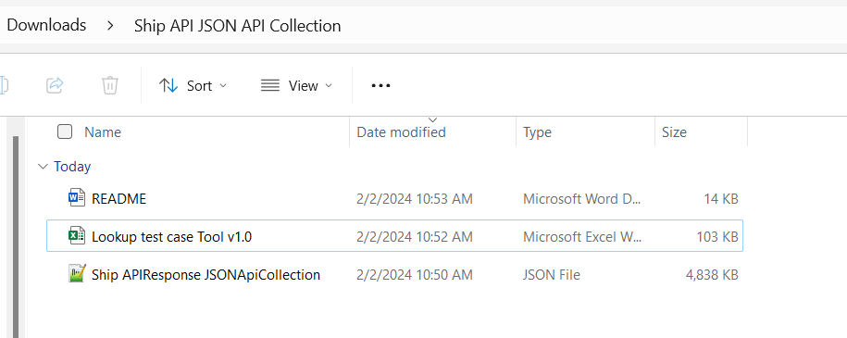

- Step 2: Open this file & apply the filters that would best fit your use case scenario. For example, I am looking for “US to Canada” Shipment transaction for “Hold at Location” special service.

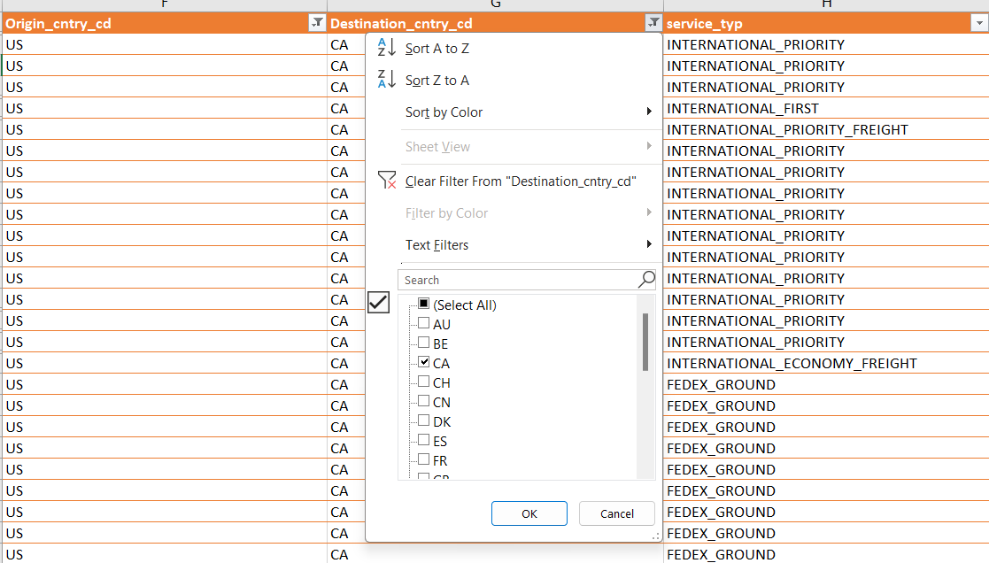

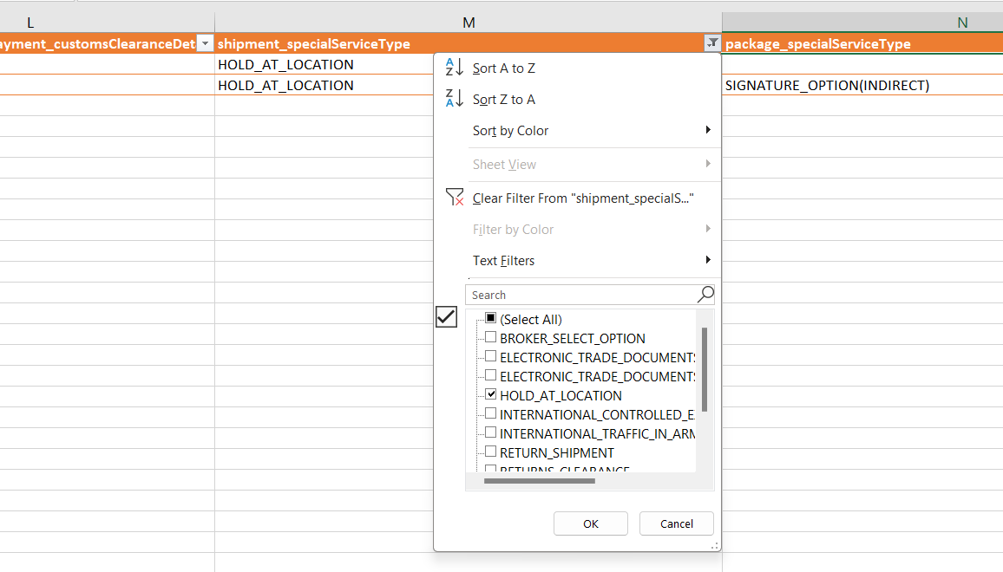

- Step 3: Once you apply the filter, you will get the list of transactions that match your use case scenario. Get the key & name from this filter.
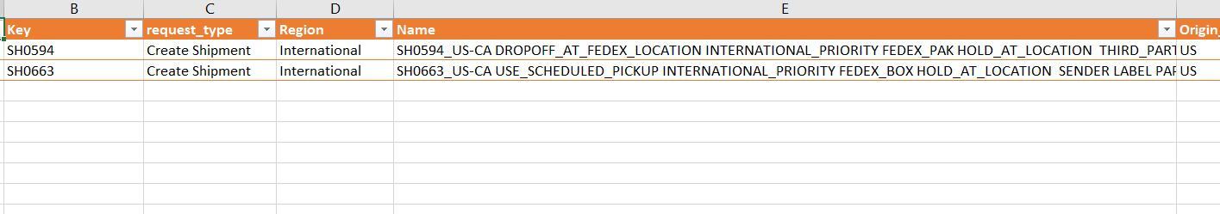For the example scenario, keys are “SH0594” and “SH0663” as shown above

How to run the specific transaction in JSON API Collection?
- Step 4: Import the JSON API Collection into suite of your choice.

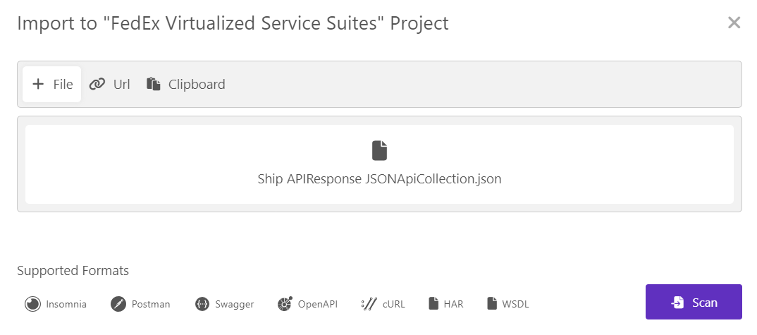

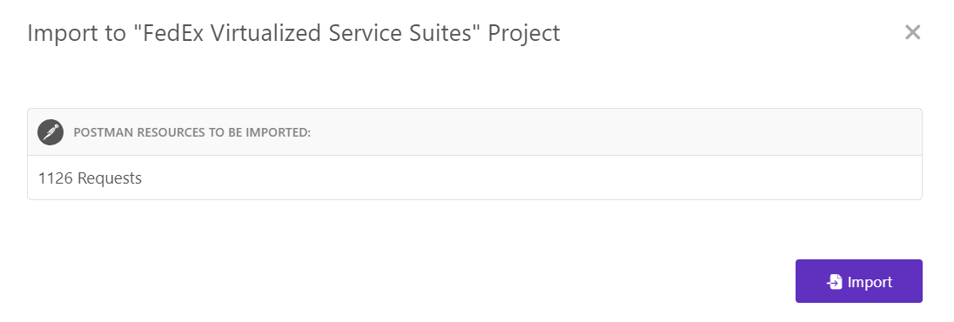

- Step 5: Apply filter based on Key that you found in Step 3 from the “Lookup Test case tool” excel.

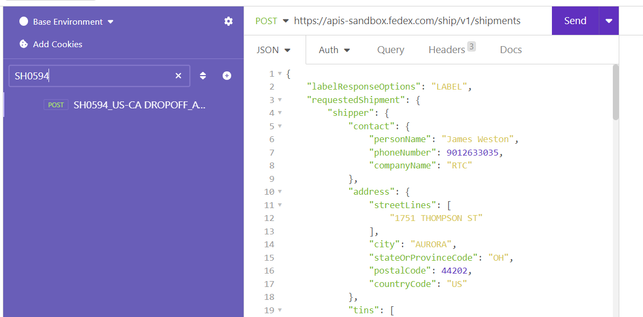

- Step 6: Run this sample transaction once you have token added into the header.

